ATM WITHDRAWAL SYSTEM – USE CASE DIAGRAM

Abstract:
The ATM Withdrawal System is an automated banking system that allows users to withdraw cash and perform basic banking operations without visiting the bank. This system uses an ATM machine connected to a bank server. The use case diagram represents the interaction between the user, ATM machine, and bank system. It explains the sequence of operations such as inserting card, entering PIN, authentication, selecting withdrawal, entering amount, checking balance, and dispensing cash with receipt.

Objectives:
- To identify the actors involved in ATM transaction.
- To represent ATM operations using use cases.
- To show interaction between ATM and Bank system.
- To understand user authentication and cash withdrawal process.
- To model real-time ATM functioning using UML.

System Description:
The ATM Withdrawal System consists of three main components: User, ATM Machine, and Bank.
The user interacts with the ATM by inserting the card and entering PIN.
The ATM machine acts as an interface between user and bank.
The bank verifies user details and checks balance before approving withdrawal.
This system ensures secure and fast transactions.

Actors Used:
- User:
The user is the person who uses the ATM to withdraw money. The user inserts the ATM card, enters the PIN, selects the withdrawal option, and receives cash and receipt.
- ATM Machine:
The ATM machine is an automated system that accepts card and PIN, communicates with the bank server, displays menu options, and dispenses cash and receipt.
- Bank:
The bank is the backend system that stores user account details. It authenticates the user, checks balance, and approves or rejects transactions.

Use Cases Used:
- Insert Card
- Enter PIN
- Authenticate User
- Display Menu
- Select Withdrawal
- Enter Amount
- Withdraw Amount
- Check Balance
- Dispense Cash and Receipt

Explanation of Each Use Case:
1. Insert Card
The user inserts the ATM card into the machine. The ATM reads the card information and prepares for authentication.
2. Enter PIN
The ATM prompts the user to enter the Personal Identification Number (PIN). The entered PIN is encrypted and sent to the bank for verification.
3. Authenticate User
The bank verifies the card details and PIN. If the details are correct, the user is authenticated. If not, the transaction is terminated.
4. Display Menu
After authentication, the ATM displays menu options such as withdrawal, balance inquiry, and mini statement.
5. Select Withdrawal
The user selects the withdrawal option from the displayed menu.
6. Enter Amount
The ATM requests the user to enter the amount to be withdrawn. The user enters the required amount.
7. Check Balance
The ATM sends a request to the bank server to check if sufficient balance is available in the user’s account.
8. Withdraw Amount
If sufficient balance is available, the bank authorizes the withdrawal and deducts the amount from the user’s account.
9. Dispense Cash and Receipt
The ATM dispenses the cash and prints the transaction receipt for the user.

System Boundary:
The system boundary is represented as a rectangle named “ATM Machine”.
All use cases such as insert card, enter PIN, authenticate user, withdrawal, and dispense cash are inside the system boundary.
Actors such as User and Bank are placed outside the system boundary.
Relationships Used:
- Association:
Shows the interaction between actors and use cases.
Example: User is associated with Insert Card, Enter PIN, and Enter Amount.
- Communication Link:
ATM communicates with Bank for authentication and balance checking.
Working Principle:
The ATM system works on client-server architecture.
The ATM acts as a client and the bank server acts as a backend system.
Whenever the user performs an action, the ATM sends a request to the bank server and waits for response before continuing the process.

USECASE DIAGRAM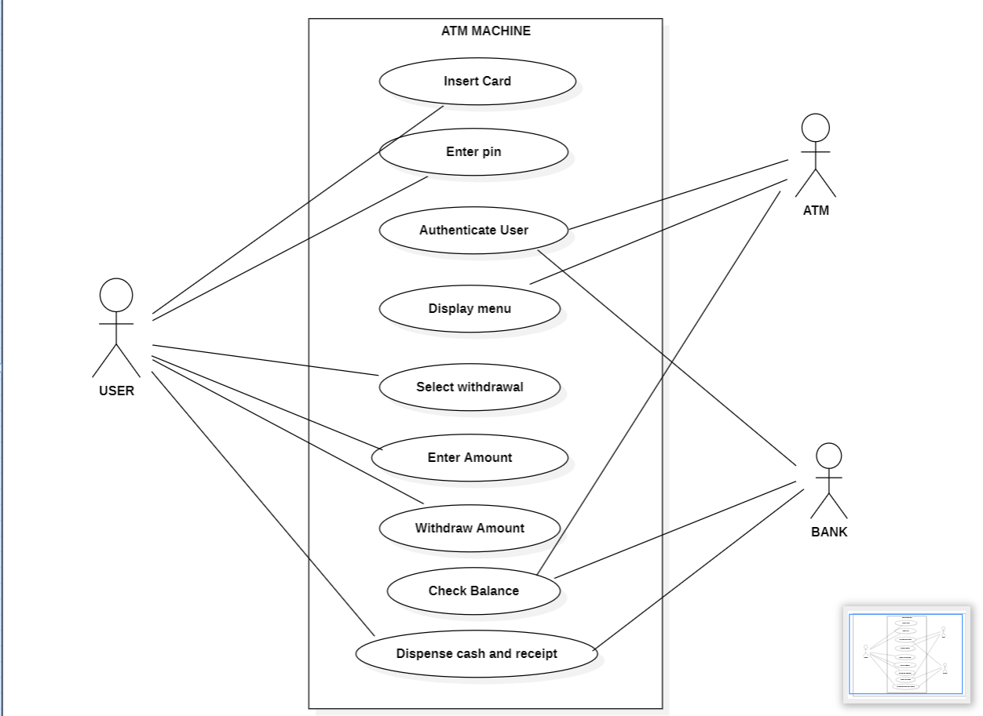

Conclusion:
The ATM Withdrawal System Use Case Diagram clearly represents the interaction between the user, ATM machine, and bank system. It explains how the user withdraws money by inserting card, entering PIN, and selecting withdrawal option. The bank verifies user details and checks balance before allowing withdrawal. Thus, the use case diagram provides a clear understanding of ATM operations and system behavior.

